LLM Evaluation Framework

Metrics- Faithfulness
Input: What is Selenium
Actual output: Selenium is a web automation framework for testing web applications
Retrieval context: Selenium is a web automation framework for testing web applications
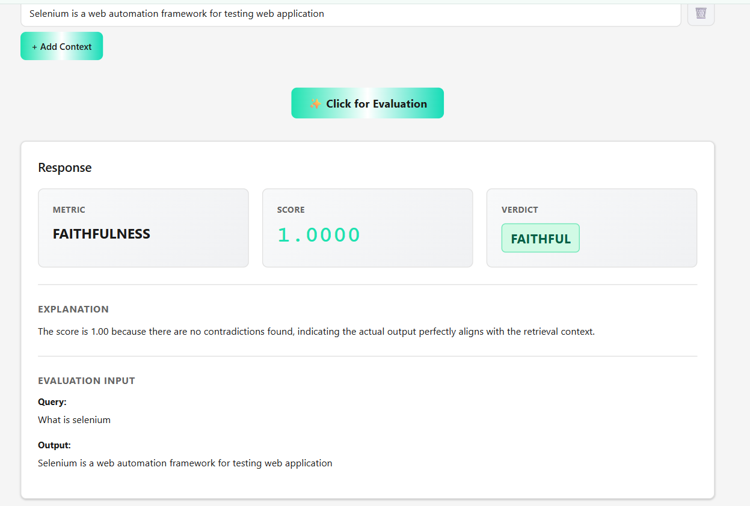

Metrics-Faithfulness
Input: What is Selenium
Actual output: Selenium is a web automation framework for testing web applications
Retrieval context: Selenium is a rare element
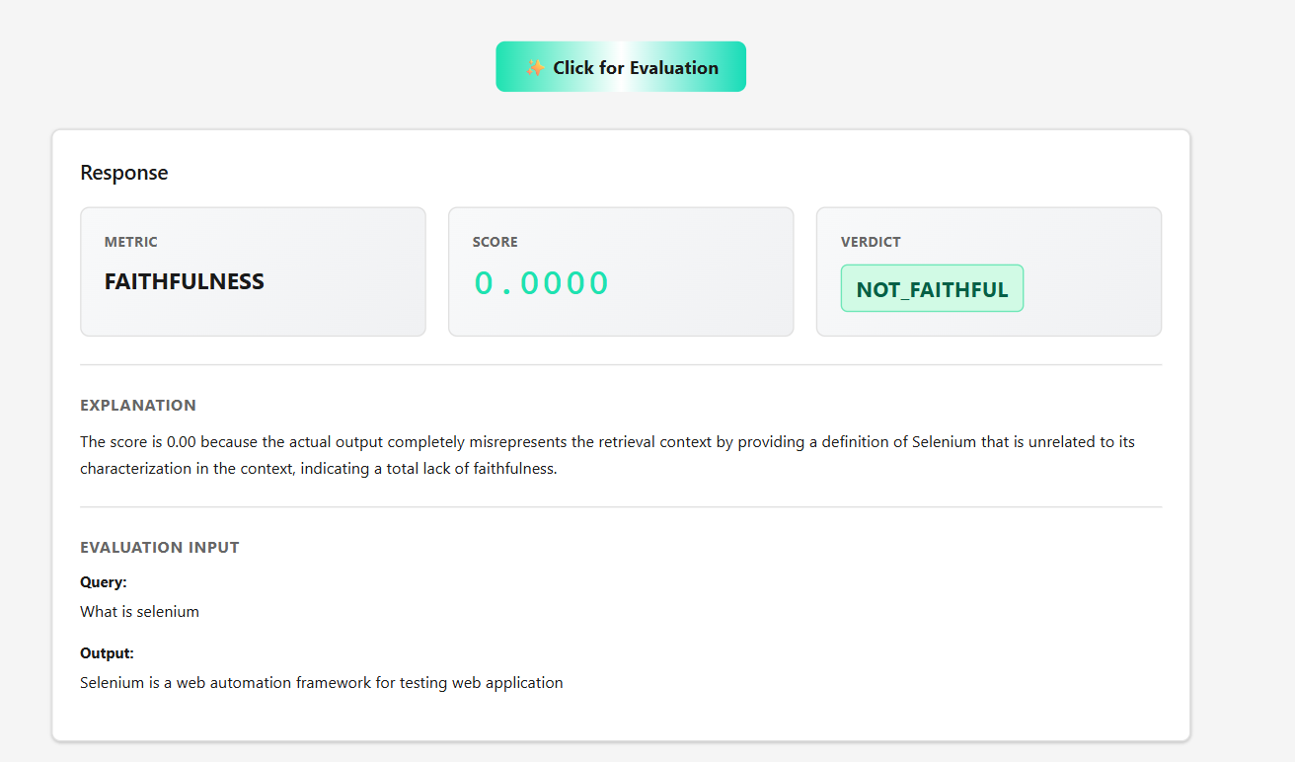

Metrics-Faithfulness
Input: What is Selenium
Actual output: Selenium is an automation framework for testing web and desktop applications
Retrieval context: Selenium is a web automation framework for testing web application (From Mongo) 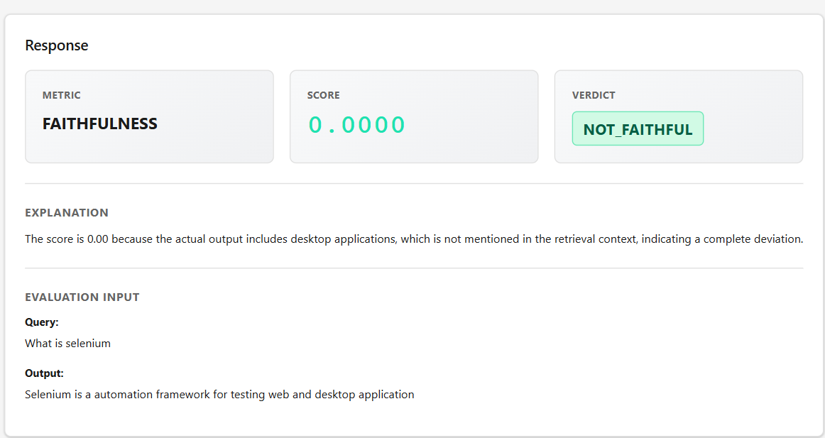

Scenario 4
Baahubali is brave.
Baahubali fights Bhallaladeva.
Baahubali is brave.
Baahubali fights Bhallaladeva.
Baahubali goes to space.
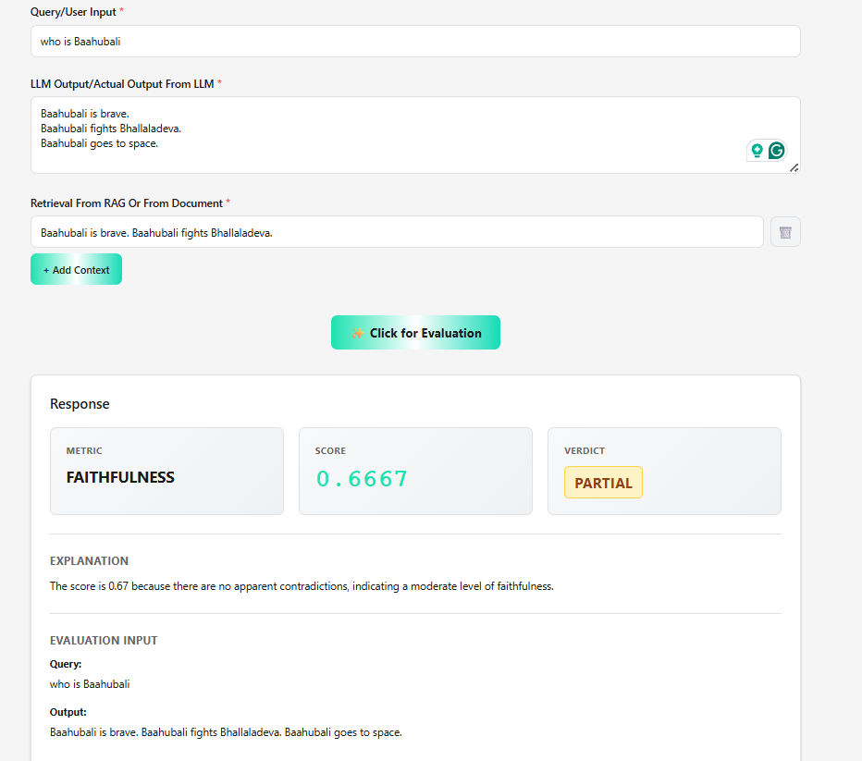

Scenario 5
Velu is a Kabaddi player.
Velu saves Dhanalakshmi from Muthupandi.
Velu hides her in Chennai.
Velu is a Kabaddi player.
Velu saves Dhanalakshmi from Muthupandi.
Velu hides her in Chennai.
Velu later becomes the Chief Minister of Tamil Nadu.
